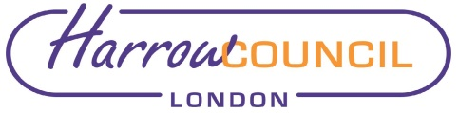
Report for: | Cabinet
Date of Meeting: 13 October 2022
Subject: Household Support Fund Third Iteration
Key Decision: | Yes - it affects the whole Borough and spend over £500k  .
Responsible Officer: | Alex Dewsnap – Acting Corporate Director, Resources
Portfolio Holder: | Councillor Stephen Greek - Portfolio Holder for Performance, Communications & Customer Experience
Exempt: | No
Decision subject to Call-in: | Yes
Wards affected: | All
Enclosures: | Appendix 1: Household Support Fund Policy Document  Appendix 2: Equality Impact Assessment

Section 1 – Summary and Recommendations
The Government announced in late August 2022 that a third iteration extension to the Household Support Fund (HSF) will be made available to Local Authorities (LAs) in England to support those most in need to help with the rising cost of living. This funding will cover the period 01 October 2022 to 31 March 2023 inclusive.

Harrow Council has been allocated a grant of £1,476,707.18, which must be spent by 31 March 2023. Household Support Fund 3’s main objective is to provide support to vulnerable households with significantly rising living costs, with a greater emphasis on offering support with energy bills, whilst food and water bills also remain priorities.

This paper proposes how Harrow Council intends to spend the indicative Household Support Fund by 31 March 2023.

Recommendations:

Cabinet is requested to approve:

- the allocation of the third extension of the Household Support Fund as set out in this report;
- the purchase of select codes vouchers from Blackhawk to a value of £181k;
- the transfer of approx. £753,817 to schools for them to provide free school meals (FSM) vouchers for approximately 6500 households with children during the school holidays.
- any underspend to be repurposed in the following order of priority:
  - to provide up to £7000 to the Self Neglect and Hoarding team to support up to 100 extremely vulnerable households with mental health conditions, elderly and frail as vouchers are not suitable and 27 families with No Recourse to Public Funds;
  - to top up the application-based scheme; or
  - to rent arrears, if not required elsewhere.

- the policy for the application-based scheme and the proposed administering process by the Revenues & Benefits team; and

- to delegate to the Acting Corporate Director for Resources in consultation with the Cabinet Member for Performance, Communications and Customer Experience to make technical scheme amendments to ensure the scheme meets the criteria set by the Government and the Council and remains within the indicative grant level.

Reason (for recommendations):

The recommendations in this report meet the essential criteria for the grant as set out by DWP. The Council has considered where best to focus the funding and the proposals provide a balance of support together with focus so that the funding is not spread too thinly.

The proposal for the eligible spend covers the following:

- Free school meals (FSM) vouchers, which have previously been found to provide effective support to vulnerable households with children.
- Vouchers for households in receipt of housing benefit who missed out on the Government cost of living payment and care leavers moving to independent accommodation.
- Help Harrow and the Community Hub – this joint venture with the Voluntary and Community Sector has shown to be effective in providing essential food assistance and other support quickly and effectively to any vulnerable household.
- An application-based scheme to be run by the Revenues & Benefits team, which targets households who would have been eligible for Government support but missed out because of the cut-off date.

Section 2 – Report

Introductory paragraph

Harrow Council has been allocated a grant of £1,476,707.18 to deliver Household Support Fund 3. The Council is required to provide a delivery plan to DWP by 28 October 2022 setting out how it intends to allocate the grant. The allocated grant must be spent by 31 March 2023. As the cost of living continues to be challenging, getting support to Harrow’s most vulnerable residents as quickly as possible is of paramount importance.

The DWP have provided the guidance which sets the framework within which the fund must be delivered – Household Support Fund (1 October 2022 – 31 March 2023) requires the following:

- Authorities have the flexibility to identify which vulnerable households are in most need of support and apply their own discretion when identifying eligibility. Rather than focus on one specific vulnerable group, Authorities should use the wide range of data and sources of information at their disposal to identify and provide support to a broad cross section of vulnerable households to prevent escalation of problems. Authorities should ensure that they consider the needs of various households including families with children of all ages, pensioners, unpaid carers, care leavers, and people with disabilities.

- Authorities should particularly consider how they can support those vulnerable households who are ineligible for other government support with the cost of living, including the:
- Energy Bills Support Scheme and the equivalence package confirmed on 29 July;
- Council Tax Rebate and the associated £144m Discretionary Fund;
- Cost of Living Payments for those on means tested benefits;
- £150 Disability Cost of Living Payment;
- One-off £300 Pensioner Cost of Living Payment (through the Winter Fuel Payment)
Authorities should have regard to the fact that receipt of any of the above support should not exclude a resident from receiving support through The Fund in principle and households in receipt of support from these schemes may still be in need. It remains at the discretion of Authorities to establish their local eligibility and identify those most in need in their area.
- Authorities should consider prioritising – households:
- Who are eligible for but not claiming qualifying benefits;
- Who become eligible for benefits after the relevant qualifying dates;
- Are in receipt of Housing Benefit only;
- Who are ordinarily eligible for benefits but who had a nil award in the qualifying period due to, for example, a fluctuation in income;
- Who have fuel costs but who cannot access the £400 of energy support from the Energy Bill Support Scheme or the equivalence package confirmed on 29 July.

Options considered

The recommendations seek to maximise the impact of this funding for households most in need in the Borough.

Different options of either spreading the funds more thinly to a greater number of households or giving a higher value award to less households were considered. The recommended options provide a balance of these approaches, limited by the available data, for example limited availability of email addresses. It also seeks to use proven methods of delivering focused funding to vulnerable families and residents such as Free School Meals.

Set out below is the recommended split of funding across different streams. The value of spending for each may alter depending on caseloads at the point data is extracted through the period the scheme is running.

The intention is to ensure all funding is spent by 31 March 2023 with the allocations as illustrated below.

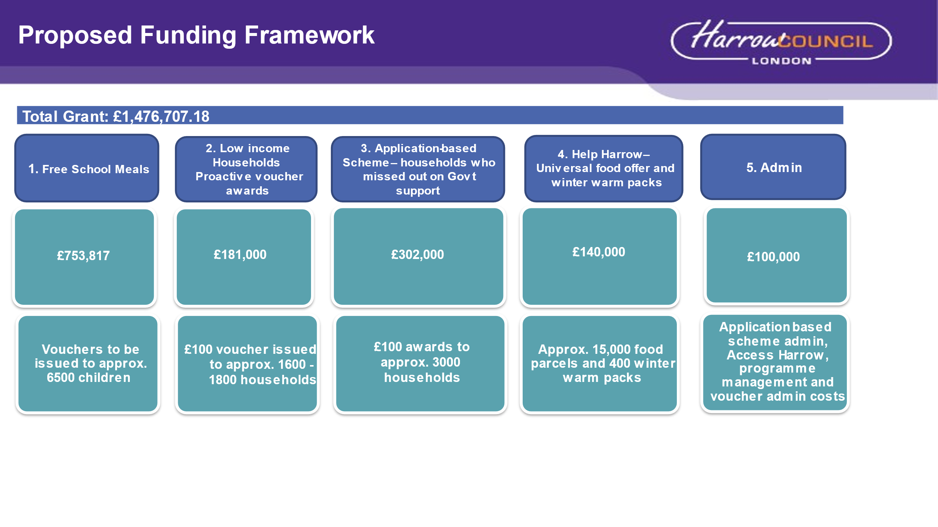

More details on each of these elements is set out below.

Free School Meals (FSM) Vouchers

We intend to continue to use this Government grant to provide free school meals (FSM) vouchers to vulnerable households with children during the school holidays from October 2022 through to Easter 2023. The value of the vouchers will be increased from £3 to £3.50/day to reflect the current rises in food prices and will include a top up of £10 for the Christmas period.

Free school meals (FSM) vouchers have been found to be incredibly effective in identifying those families in most need, helping to ensure that children continue to have access to a meal during the holidays. By providing families with vouchers we help to reduce the need to have to choose between heating and eating and free up other household income to allocate towards fuel bills. There is currently no other viable alternative to identify as many households in need of support. Schools already have voucher systems set up for those parents with children on free school meals, making the Council’s schools funding a very efficient and effective way of giving financial support to families whose children qualify for free school meals.

Low-income Households

In accordance with the DWP guidance to target an array of vulnerable groups and to exercise local discretion, using data and advice from professionals in Council services, the following groups have been identified as being most in need in Harrow because they have missed out on Government cost of living payments or are deemed to be particularly vulnerable. They are also groups we can proactively identify as a council and have contact information for so we can proactively target these groups with the issuing of a voucher or direct support:

- Approximately 1626 households on housing benefit only as this group is not eligible for the means-tested Cost of Living Payments unless of pension age or eligible for a Disability Cost of Living Payment.
- 100-120 care leavers moving to permanent accommodation who would not have been eligible for any government support due to the qualifying dates.
- An allocation up to £7k to enable Council teams working directly with an estimated 27 individuals who are known to the Council but who have No Recourse to Public Funds (15 households with children in the household & 12 current allocated cases to specialist Children in Need, First Response, and Children with Disability teams) and up to 100 extremely vulnerable households who are supported by the Self Neglect & Hoarding team, who have mental health conditions, are elderly or frail, to be able to offer direct support as vouchers are not an accessible option for to these groups.

Blackhawk Voucher Scheme

The issuing of the voucher codes will be administered by the Blackhawk company, which has previously been used by the Council in HSF1.

The select codes were chosen in lieu of energy cards as they don’t cover prepaid meters and therefore risk some households in need not being able to use the voucher.

The select codes aim to free up money that would otherwise have been used on food and other essential items like winter clothes, blankets and energy efficient cooking methods, for households to cover utility bills and other expenses. Select codes are also universally applicable in a variety of outlets including all major supermarkets and major retailers like Argos, the Range and Wilko, providing recipients with greater choice. They are relatively straightforward and quick to administer and have an 1.2% discount rate. They are covered by the Crown Commercial Framework so there is no requirement for new terms and conditions as additional clauses can be added to the existing account to reflect the new requirements.

The voucher codes will have a value of £100 and will be valid for 3 months and will be sent out by post by Blackhawk directly. The Council will follow this up with reminder letters after the first 4 weeks to maximise the redemption rate. The target redemption rate for the Blackhawk voucher scheme is 85%, based on previous schemes as part of the same Government grant.

Any underspend on unredeemed vouchers will be recycled into £7k for the self-neglect and hoarding team and NRPF, the application-based scheme or to rent arrears.

Application-Based Scheme

The only stipulation in this round of the Household Support Fund is for the scheme to have an application based element. The proposed application scheme for Harrow will be aimed at households who would have been eligible for Government support but have missed out because of the cut-off date. Due to the budget available, the amount awarded will be lower than the Government payments. The criteria have been set in accordance with the government guidance referenced above, the ability to be able to identify and validate eligibility in the most cost-efficient way and to enable a meaningful amount to be awarded.

Eligibility criteria:
- Started to receive a qualifying means-tested benefit between 26 April 2022 to 25 May 2022 and 30 September 2022 that would have resulted in entitlement to the low income and tax credit cost-of-living payment.
- Households who had a nil award during the qualifying period.
- Are liable for the fuel bills.

The amount available will be used to issue up to 3000 £100 awards as a flat rate amount via BACs. If there are any exceptions that cannot receive the money via BACs for any reason then we can use allpay cards.
The scheme will accept applications from 1st November 2022 to 31 January 2023. The application scheme will close as soon as there is a risk of funds running out and it will be administered and expenditure continuously monitored by the Revenues & Benefits team.
The Council will also develop a Communications and Engagement Plan, working with voluntary and community groups to raise awareness of the application based scheme, ensure those who are eligible apply and ensuring that relevant teams and organisations have the necessary information to signpost residents to available support.

Key planned activities include:

- Communications and outreach planning and coordination with the Council’s Communications team.
- Send reminder letters to those issued with vouchers and not yet redeemed.
- Continuously monitor redemption rates to coordinate and target content outputs.
- Fund additional capacity to Access Harrow to deal with incoming customer queries.
- Ensure Access Harrow and front-line services (housing, children’s front door, adult social care) are aware and have sufficient information about the application scheme and its criteria to signpost service users.
- Work with Voluntary and Community Sector organisations (Citizens Advice, Harrow Association of Disabled, the Information & Advice Network) to promote the application-based scheme.
- Combine Household Support Fund mailshots with other information and advice and signposting to other support available.

Community Hub & Help Harrow

It is proposed that Household Support Fund is used to fund the Community Hub for the period 1st October to 31st March 2023. This will enable the continuation of crucial food provision to households in need, which continues to be one of the priorities in this strand of DWP guidance.

Many households face a decision between heating or eating, as the winter months approach the demand for food parcels will increase, as has been shown by previous years and the graphs below. By making access to food provision available it helps free up money to be used on other household expenses and utility bills.

The Help Harrow project has proven to being effective in providing food and other essential support to a wide range of vulnerable residents. The Community Hub via the Help Harrow online platform offers a universal food provision and other essential products including Winter Warmth packs, to any vulnerable household, regardless of benefits status. The fact the Community Hub is a universal offer where people can self-refer removes the stigma associated with other foodbanks where you have to be referred or register which is often cited as a barrier for why people who need help, do not come forward to ask for it. Every Friday the community kitchen runs a Surplus Food Market.​ Residents can self-refer via the Help Harrow platform and organisations can make referrals on behalf of people, including refugees and asylum seekers. ​

The Hub also plays a valuable role in the local community, it provides food stock and support to a wider food network in the borough including a weekly Romanian and Eastern European foodbank and provides training and work experience projects such as cooking classes, advice on energy efficient meals, apprenticeships.​ It also runs food drops out of schools and supports schools through the Urban Farm and Plant to Plate projects. ​

- The Community Hub is supported by a team of 80 active volunteers.

- The number of food deliveries made by the Hub have increased fivefold over the last 6 months, compared to the level of support being provided during Covid Lockdowns with a record 1000 deliveries made in September 2022

- A third of those receiving food support are households with children

- Since the start of the year the main reason given for needing support has switched from Health (Covid) to hardship, disability and unemployment.

- The largest group seeking support are Asian/British Asian, followed by White British and Black or Black British

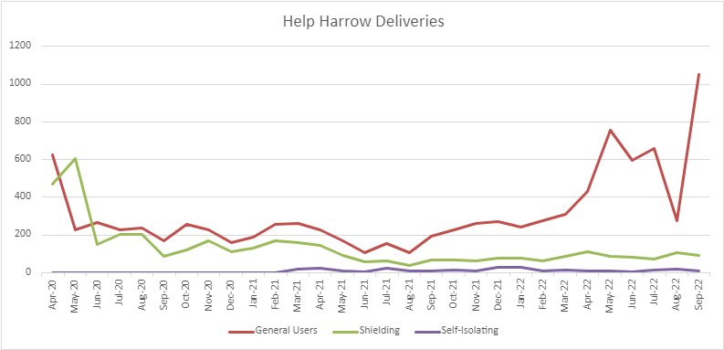

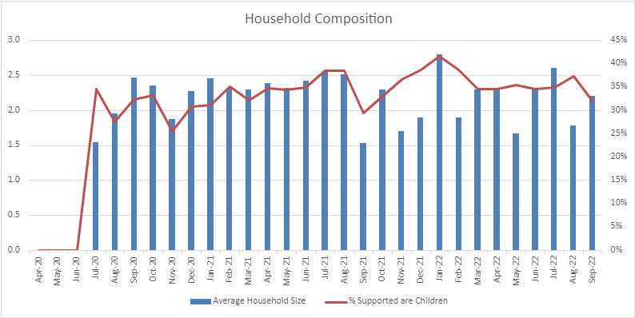
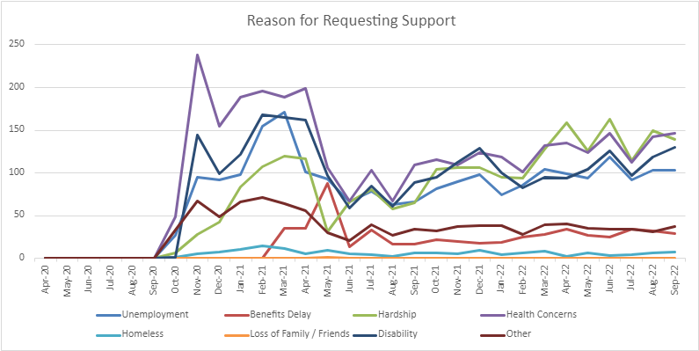

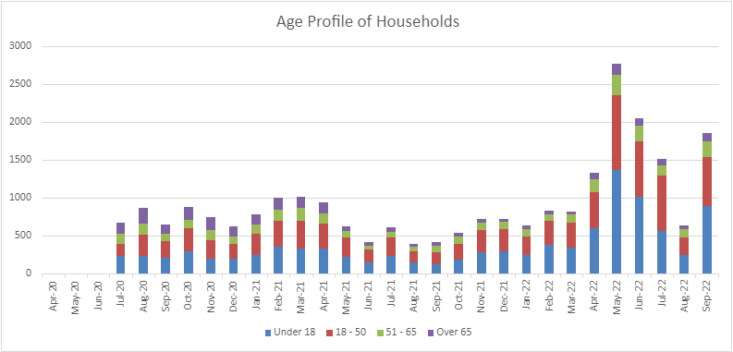
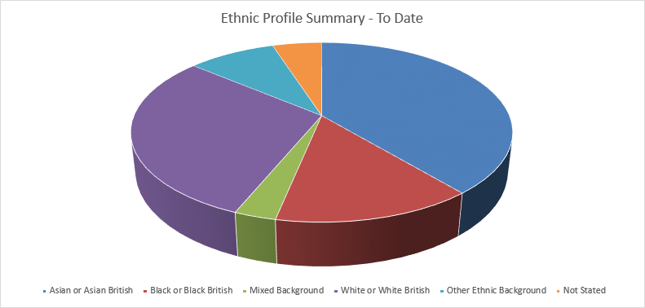
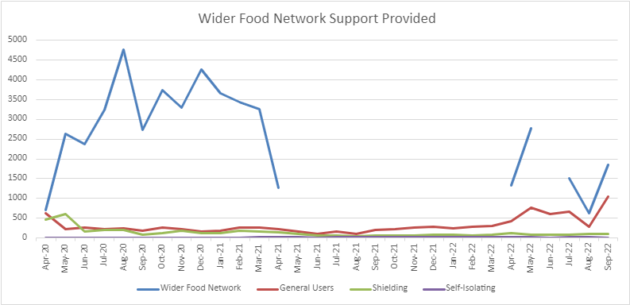

Last winter the Community Hub handed out approximately 400 winter warmth packs made up of donated items including blankets, items of clothing etc. There are items that would be useful to include in the packs this winter that may not be able to be sourced though donations like thermals, wearable blankets, hand warmers, so up to £5000 from the Household Support Fund will be made available, if required, to top up the £5000 Public Health are contributing to the purchasing of these additional products.

Administrative Costs

The DWP permit local authorities to use a reasonable amount of the Household Support Fund to pay for administration of the scheme.

The Council will use £100k of the grant on application scheme administration and support, mailshots and admin for the Blackhawk voucher scheme. Where is it possible, the Council will use existing capacity within the organisation to support any administrative activity, so the allocation of the grant to Administration costs can be minimised.
Ward Councillors’ comments
Not applicable.

Performance Issues

Performance will be tracked through:

- Monthly monitoring reports provided by Blackhawk on vouchers’ redemption.
- Free school meal voucher usage through schools; and
- Help Harrow monitoring information.

Environmental Implications

There are none.

Data Protection Implications

A data protection impact assessment has been completed and our systems are already data compliant, then there are not considered to be any key data protection risks.

Risk Management Implications

Risks included on corporate or directorate risk register? No

Separate risk register in place? No

The relevant risks contained in the register are attached/summarised below.

The following key risks should be taken onto account when agreeing the recommendations in this report:

Risk Description | Mitigations | RAG Status
Risk of unmanageable demand for the application-bases scheme  Insufficient funds available to support resulting in overspend and reputational risk in case of having to close scheme early | - Application-based scheme – impossible to predict demand with certainty - either not sufficient demand or too high demand.  - The eligibility criteria is very tight and there will be regular review to monitor any potential overspend and comms activity to the public will be coordinated and expectations will be managed.  - For any underspent funds to be repurposed to alternative grant elements. | Amber
Funding overspend or underspend  Risk of underspend on application scheme or any other elements – too few applications. | - Regular review of allocations against outcomes predicted will be carried out to ensure there is no overspend or underspend.  - Blackhawk vouchers - relatively low element, expected redemption at least 85 %. Any unredeemed funds will be rebated and can be repurposed.  - FSM vouchers – any left-over FSM funds will be retained to cover any FSM overspend due to an increase in the number of children receiving FSM over the course of the HSF scheme.  - Other elements of scheme – funding is limited to the amount allocated so any increase in demand will not be met. | Amber
Risk that sustaining the activity in the programme is dependent on continuing to receive the Government grant which creates a funding cliff edge if and when the Government grant comes to an end. | The Council will work with partners to review the support the grant is currently funding and continue to make representations to Government regarding future funding. | Amber
Risk of Fraud & Misconduct | - Proven methods of delivering focused funding to vulnerable families and residents such as Free School Meals.  - Databases are held by the relevant teams such as the Revenues & Benefits team and recipients can be identified and necessary checks are carried out. | Amber
Risk of funding not being committed by the March 2023 deadline | - Most elements of the scheme are proactive issue of awards so do not need to be claimed by residents which reduces the risk of underspend.  - Publicity will be undertaken to raise awareness, in particular with partners who are well placed to signpost pensioners to take up the vouchers.  - Any unspent funds are currently being planned to be used to increase the rent arrears allocation to eligible pensioner and vulnerable households. | Green
Full grant funding not received as a result of DWP determining that some spend was not eligible | - Payment of the grant from DWP will be made in arrears after the interim MI return in Nov 2022 and the final MI return at the end of grant period in March 2023 after the DWP have verified the MI.  - The second will be dependent on DWP being satisfied that the LA’s MI submission evidence eligible spend within the scheme.  - Harrow’s approach takes full account of DWP guidance on spend to ensure its scheme is within the framework.  - The delivery plan will be submitted to DWP in Oct 2022. Further MI will be submitted to DWP regarding actual spend in Nov 2022. Any feedback from DWP in response to either of these submissions will be considered and implemented as appropriate to ensure the scheme remains compliant.  - There is flexibility within the scheme to adapt it and local discretion can be used to make changes to the allocation of funding across the different elements. | Green

Procurement Implications
The Council has previously entered into arrangements to support the Community Hub, which has had procurement sign off. The additional grant to be awarded to the Community Hub of £135k falls within the existing contract extension until March 2023.
The Council will purchase vouchers from Blackhawk with which the Council has an existing agreement and is part of the Crown Commercial Framework.

Legal Implications
The DWP has issued £421million to Local Authorities (LAs) to support those most in need with the rising cost of living. The funding period covers 1 October 2022 until 31 March 2023 inclusive. The funding is being provided under section 31 of the Local Government Act 2003 and local authorities are responsible for setting criteria and administering the fund. There are also requirements in relation to information sharing and submitting monitoring returns on use of the funds. The policy contains provisions in relation to combatting fraud to ensure that monies can be recovered, and action taken if any applications are submitted on a fraudulent basis.

The DWP has issued guidance on use of the fund, which sets out eligibility criteria. The guidance explains that: “the funding is intended to benefit households most in need of support with food, energy bills, related essentials, wider essentials and (exceptionally) housing costs as the economy recovers this winter. The funds should not be used for any economic undertaking. Whichever way you use the funding, including where you work in partnership with others, you should consider all Subsidy rules (previously state aid) issues. Check whether the ‘de minimis’ regulation exception applies. You should also follow government procurement procedures where relevant.”

The Council is expected to use a range of data and sources of information to identify and provide support to a broad cross section of vulnerable households. The Council must have a clear rationale or documented policy/framework outlining its approach including defining eligibility and how the scheme is accessed. Receipt or eligibility for other support should be taken into account to avoid duplicating provision where possible.

The Council is permitted to provide a basic safety net to support individuals regardless of their immigration status if there is a genuine care need that does not arise solely from destitution. To evidence this, there should be an assessment of community care needs, serious health problems or a risk to a child’s wellbeing. Individuals with no resource to public funds can be supported in accordance with specific legal powers connected to the aforementioned assessments.

The Council must have effective systems in place to combat fraud. If administration is via a third party, suitable due diligence checks must be carried out to ensure they are viable and able to deliver the scheme. There should be appropriate checks in place to verify the identity of those who are eligible. Any suspected financial irregularity must be reported to the DWP, explaining what steps are being taken to investigate the alleged fraud or other impropriety.

Reasonable administration costs can be recouped from the grant. Such administration costs will be published in the Gov.uk website alongside details of all spend.

Financial Implications

Harrow Council has been allocated a grant of £1,476,707.18, which must be spent by 31 March 2023. This funding will cover the period 01 October 2022 to 31 March 2023 inclusive. £100k of the grant can be applied to administering the application based scheme. For Harrow this will include scheme administration and support, mailshot and admin for the Blackhawk voucher scheme. Where it is possible, the Council will use existing capacity within the organisation to support any administrative activity, so the allocation of the grant to Administration costs can be minimised.

Equalities implications / Public Sector Equality Duty

Decision makers should have due regard to the public sector equality duty in making their decisions. The equalities duties are continuing duties they are not duties to secure a particular outcome. Consideration of the duties should precede the decision. It is important that Cabinet has regard to the statutory grounds. The statutory grounds of the public sector equality duty are found at section 149 of the Equality Act 2010 and are as follows:

A public authority must, in the exercise of its functions, have due regard to the
need to:

- Eliminate discrimination, harassment, victimisation and any other conduct that is prohibited by or under this Act;
- Advance equality of opportunity between persons who share a relevant protected characteristic and persons who do not share it;
- Foster good relations between persons who share a relevant protected characteristic and persons who do not share it.
- Having due regard to the need to advance equality of opportunity between persons who share a relevant protected characteristic and persons who do not share it involves having due regard, in particular, to the need to:
- remove or minimise disadvantages suffered by persons who share a relevant protected characteristic that are connected to that characteristic;
- take steps to meet the needs of persons who share a relevant protected characteristic that are different from the needs of persons who do not share it;

- Encourage persons who share a relevant protected characteristic to participate in public life or in any other activity in which participation by such persons is disproportionately low.

- The steps involved in meeting the needs of disabled persons that are different from the needs of persons who are not disabled include, in particular, steps to take account of disabled persons’ disabilities.

- Having due regard to the need to foster good relations between persons who share a relevant protected characteristic and persons who do not share it involves having due regard, in particular, to the need to:
- Tackle prejudice, and
- Promote understanding.

Compliance with the duties in this section may involve treating some persons more favourably than others; but that is not to be taken as permitting conduct that would otherwise be prohibited by or under this Act. The relevant protected characteristics are:

- Age
- Disability
- Gender reassignment
- Pregnancy and maternity
- Race
- Religion or belief
- Sex
- Sexual orientation
- Marriage and Civil partnership

An equality impact assessment (EQIA) has been undertaken for this proposal the EQIA concludes that:

There will be a positive impact on working households with children.

There will be a positive impact on residents in receipt of housing benefit.
- There will be a positive impact on vulnerable households.

- There will be a positive impact on Harrow residents who can take advantage of the ongoing food resource via the Community Hub.

Mitigations are set out in the Equality Impact Assessment.
An updated announcement of the extension of the Household Support Fund will be published on Harrow’s website, which meets the general accessibility criteria.

Section 3 - Statutory Officer Clearance
Statutory Officer: Sharon Daniels
Signed on behalf of the Chief Financial Officer
Date: 03/10/22
Statutory Officer: Hugh Peart
Signed by the Monitoring Officer
Date: 03/10/22
Chief Officer: Alex Dewsnap
Signed off by the Acting Corporate Director
Date: 03/10/22
Head of Procurement: Nimesh Mehta
Signed by the Head of Procurement
Date: 29/09/22
Head of Internal Audit: Susan Dixson
Signed by the Head of Internal Audit

Date: 03/10/22

Mandatory Checks
Ward Councillors notified: NO, as it impacts on all Wards
EqIA carried out: YES
EqIA cleared by: Head of Equality, Diversity and Inclusion (EDI)

Section 4 - Contact Details and Background Papers
Contact: Angelica Stoichkov, Policy Officer, Angelica.Stoichkov@harrow.gov.uk.

Background Papers: None

Call-in waived by the Chair of Overview and Scrutiny Committee - NO

